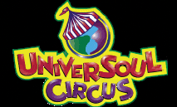
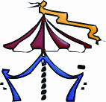
Freeman’s Barber Shop
&
Kappa Alpha Psi Fraternity, Inc.

Sponsors the Fourth Annual


"Kappa Night at the UniverSoul Circus"



Friday, June 3, 2005
7:30 PM

at the
CAPITAL PLAZA
ON ANNAPOLIS RD, ROUTE 450
(parking lot of the former Montgomery Ward Store)

REDUCED TICKETS ..........................$23.00
Call for further information: (301) 350-5399 or (301) 350-3166

